

Software Project – Clothing Store

**Ben Sharkey**

**N00212320**

Software Project

e.g. Develop an event ticketing application

Year 2 2022-23

DL836 BSc (Hons) in Creative Computing

Link to resources created as part of the project.

|  |  |
| --- | --- |
| GitHub | <https://github.com/y2-SW-project/swproject23-Poggs5401> |
| Video | Link to your video file (MS Stream, YouTube) |

Table of Contents

1 Introduction 1

2 Business Concept 2

2.1 Business Idea 2

2.2 Business model 2

2.3 Market Research 2

2.4 Marketing/Advertising 2

2.5 Suppliers 2

2.6 Competitors 2

2.7 Employees 2

2.8 Environmental Impact 2

3 Requirements 3

3.1 Introduction 3

3.2 Requirements gathering 3

3.2.1 Similar applications 3

3.2.2 Interviews 3

3.3 Requirements modelling 3

3.3.1 Functional requirements 3

3.3.2 Non-functional requirements 3

3.3.3 Use Case Diagrams 4

3.4 Feasibility 4

4 Web application Design 6

4.1 Layout 6

4.2 Interaction 6

4.3 Colour schemes 6

4.4 Font choices 6

4.5 Wireframes 6

5 Database Design 7

5.1 Description 7

5.2 Business Reporting Requirements 7

5.3 Textual Representation of Data-Set 7

5.4 Business Rules 8

5.5 Entity Relationship Diagram 8

5.6 Tables 9

5.7 Database Dictionary 10

6 System Design/ Architecture Overview 11

6.1 Introduction 11

6.2 Model View Controller 11

6.3 User Authenticaion 11

6.4 Routing 11

6.5 Templating 11

7 Testing 12

7.1 Introduction 12

7.2 Functional Testing 12

7.2.1 Login/Registration 13

7.2.2 Navigation 13

7.2.3 Calculation 13

7.2.4 CRUD 13

7.2.5 Discussion of Functional Testing Results 14

7.3 User Testing 14

7.4 Conclusion 14

8 Project Management 15

8.1 Introduction 15

8.2 Project Phases 15

8.2.1 Requirements 15

8.2.2 Design 15

8.2.3 Implementation 15

8.2.4 Testing 15

8.3 SCRUM Methodology 15

8.4 Project Management Tools 16

8.4.1 Github Project 16

8.4.2 GitHub 16

9 Reflection 17

9.1 Your views on the project 17

9.2 How could the project could be developed further? 17

9.3 Assessment of your learning. 17

9.4 Completing a large software development project 17

9.5 Technical skills 17

9.6 Further competencies and skills 17

10 References 18

# Introduction

Overall aim

Application area

Technologies

PHP, MySQL, Bootstrap, CSS, Vanilla

Tools

IDE, phpMyAdmin, Miro

Project management

GitHub

Business Concept

Requirements

Design

Implementation

Testing

Reflection

# Business Concept

## Business Idea

A clothing store in which the defining feature is the ability to filter and search for clothes by color, allowing consumers to color code outfits more easily. Another feature is automated suggestions that would match pieces of clothing you pick out, for example if a consumer were to pick a white and purple shirt, the site would recommend trousers of similar color and style.

## Business model

The store generates profit through the sales of clothing listed on the site. It is based on an online-only model, not boasting any physical locations.

## Market Research

**Market for Product/Service**

The target audience for this application would be people with active social and professional lives, as they would be more inclined to create color-coded outfits to impress friends/clients.

**Customers - Demographics, Profile**

The ideal demographic for the products listed on the site would be consumers in their 20s or 30s as that is when the average person is the most active from a social standpoint.

## Marketing/Advertising

Due to the target demographic being in their 20s or 30s the marketing/advertisement strategy for the application would be primarily based on social media, investing in campaigns on platforms such as Instagram, Facebook and TikTok.

## Suppliers

The store would be supplied by local textile purveyors such as Roisin Cross, TWI, and CLOTH. This is to avoid the various harmful conditions of wholesale fabrics such as increased shipping time and distance, poor working conditions and mediocre quality.

## Competitors

The direct competitors for such a clothing store would be major clothing retailers such as Penney’s, H&M and Dunne's Stores.

## Employees

The primary place of employment within the business would be based in a warehouse setting, designing, packing, and shipping the clothing pieces and orders. The online-only model allows for the quantity of employees to be low due to there being no need to employ store employees for physical locations, thus keeping costs low from this standpoint.

## Environmental Impact

As mentioned before the store would obtain its supplies locally, eliminating the enormous amounts of carbon emission caused by overseas shipping. The shipping of the final product itself would be done using ground-based transport methods as well as the product being packaged with recycled boxes and envelopes and the labels for which being produced using thermal printers, mitigating the effects of excessive ink usage on the environment.

# Requirements

## Introduction

The purpose of the requirements phase is to allow for developers to work out what the application should be able to do. It is important to understand what the users would like the application to do rather than the developer deciding what is required.

You can write a bit about your project area. Each paragraph has a blank line between it and the previous paragraph

## Requirements gathering

### Similar applications

Look at and document 2 similar applications. Be sure to include the following for each:

* Screen shots
* Descriptions
* Advantages
* Disadvantages

**ASOS**

ASOS is an online-only clothing store that sells over 850 brands as well as its own range of clothing and accessories, and ships to all 196 countries from fulfilment centers in the United Kingdom, the United States, and Europe.

**Pros;**

• ASOS boasts a wide range of clothing for both men & women, this allows them to have a very wide audience as they have clothes for people of all shapes and sizes.

• Clothes are affordable with sales constantly being held, keeping the entry point low for consumers.

**Cons;**

• ASOS offers next day delivery across Europe, this often means the company in question is using fast shipping methods with little care for the environment.

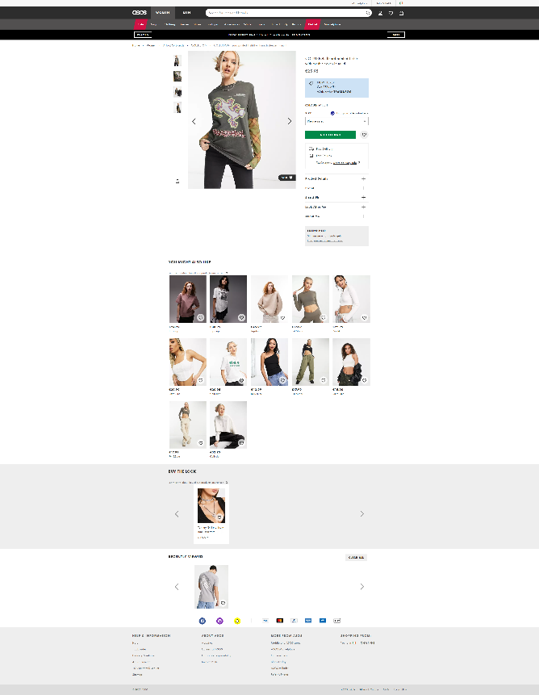

**Zalando**

Zalando is a leading online platform for European fashion and lifestyle. Founded in 2008, Zalando now delivers over 6,500 brands to 25 countries across Europe.

**Pros;**

• Zalando offers free delivery if your order meets a minimum spend of €30

• Shipping times vary depending on location of customer, this is a good sign as it indicates that the company may be using ground-based shipping methods, decreasing carbon emissions.

**Cons;**

• Zalando only ships to Europe, this decreases the company's audience and scope, and therefore their potential profit.

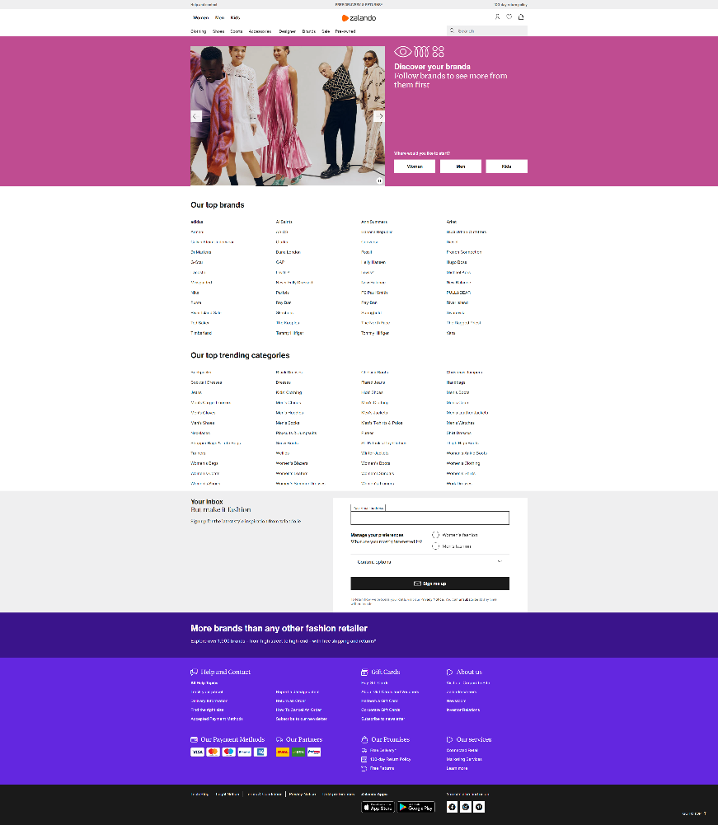

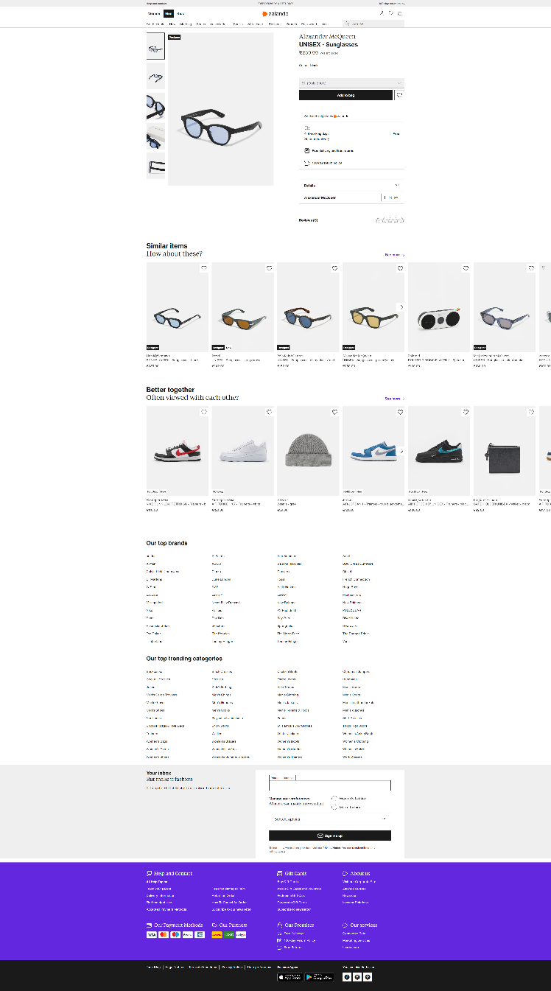

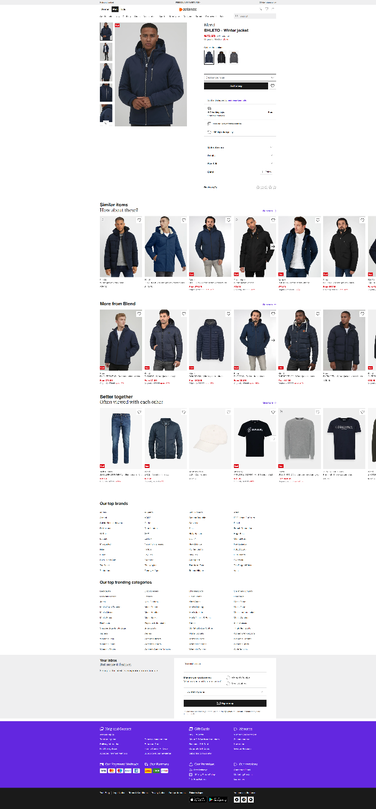

### Interviews

Conduct interviews with 2 or 3 users to find out what the important features for them for the app are. There may be various issues that arise in multiple interviews. These can be grouped together into a number of themes.

I chose to conduct my interviews using a Microsoft Form as it allowed me to compile the data easily. The most common requested features were a wide selection of filters as seen in the screenshot below;

As far as features those interviewees had found to be an annoyance in the past goes, the most common was unwanted popups and conditional discounts as seen below;

## Requirements modelling

### Functional requirements

Create a numbered list of what the application should be able to do. Start with the most important feature.

**The application should realistically be able to achieve the following;**

• Allow the consumer to find their desired clothing both quickly and easily.

• Have a consistent design that’s easy on the eye and simple to use for anyone in order to broaden the audience.

• Feature a wide range of the advertised product, in this case clothes.

• Allow the consumer to pay with multiple methods and feature a stress-free and safe checkout system.

### Non-functional requirements

These are requirements which if not met do not stop the application from working, but which mean that the application is not working as well as it should. They are usually based on issues such as:

* Usability
* Performance
* Security

**The following are example of non-functional requirements for the application;**

• A responsive layout based on Bootstrap.

• Feature secure domain grounds with HTTPS.

### Use Case Diagrams

Consists of actors and use cases. You should document each individual use case.

Delete the following diagram and insert your diagram. Use draw.io

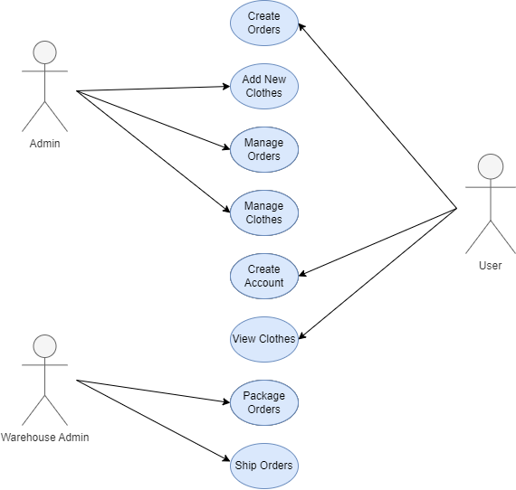

## Feasibility

This section describes which technologies are planned to be used in the development of the application. It then explains if there are any issues in terms of the technical feasibility of the project, for example, if there are two different types of software which may have compatibility issues.

# Web application Design

## Layout

The application is based on the Bootstrap Framework. It will feature a high level of customization as well as many of the pre-defined Bootstrap components.

## Interaction

The user can interact with the website in multiple ways, between buttons for both their shopping carts and profile, as well as an interactive carousel showing off the latest clothing the application has to offer.

## Colour schemes

Describe the colour palette that you will use consistently across the web application

The colour palette primarily consists of three greyscale colours;

#404040

#D2D2D2

#9D9D9D

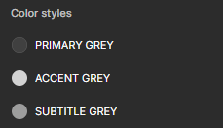

## Font choices

Specify the fonts that you will use for different types of text. Include samples for paragraph text, headings and bold and italicised text.

The application

## Wireframes

Describe how to navigate from one page to the next by adding a diagram of the different screens and what the main functionality is.

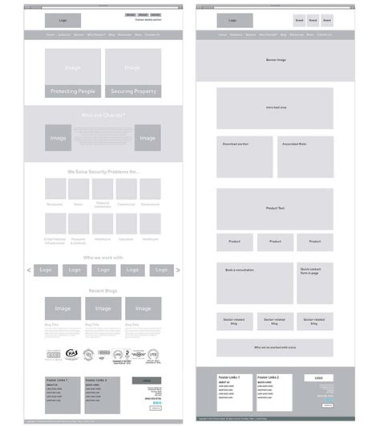

# Database Design

## Description

A company has a website that sells clothing of a variety of colours. They would need a database for all their clothing and orders. For each order placed, they would need clothing bought, total price and date of the order. The database needs to keep track of all clothing that is being sold. Customers will have to input their information when registering an account. Customers will also have to input their card details when making a payment for their order.

## Business Reporting Requirements

1. Admins need to be able to create, read, update, and delete: clothing and users.
2. Users will need to be able to find all clothing available on the site.
3. Users may want to find a product by its colour.
4. Users need to be able to store the products they wish to buy in a shopping cart.
5. Users need to be able to create and view their own account.
6. Users need to be able to find products by keywords in their titles.

## Textual Representation of Dataset

**CLOTHING** (id, title, description, price, img_filename, designer_id, colour_id)

**CUSTOMER** (id first_name, last_name, address, email)

**ORDER** (id clothing_id, customer_id)

**COLOUR** (id, title, hex)

**DESIGNER** (id, name, address)

## Business Rules

• A **Customer** has many **Orders**.

• An **Order** belongs to one **Customer**.

• An **Order** holds many **Clothes**.

• **Clothes** belong to many **Orders**.

• A **Colour** belongs to many **Clothes**.

• **Clothes** can have a single **Colour**.

• A **Designer** designs many **Clothes**.

• **Clothes** can have many **Designers**.

## Entity Relationship Diagram

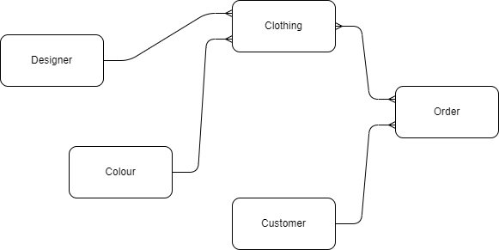

## Tables

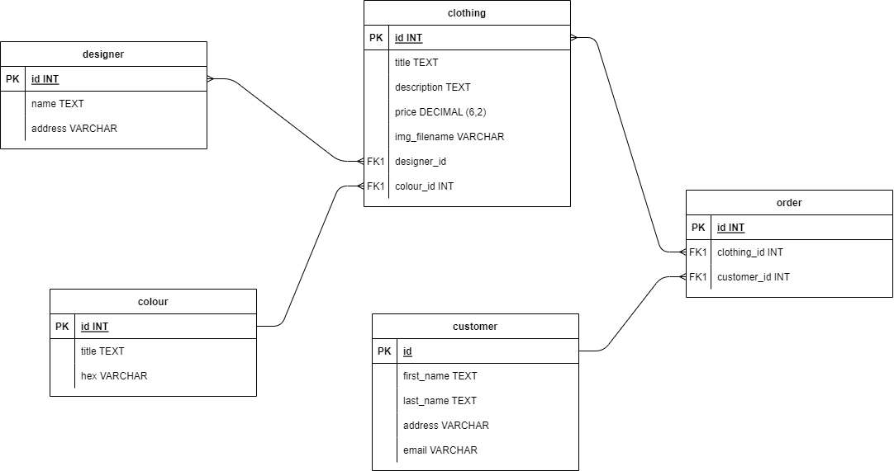

## Database Dictionary

|  |  |  |  |  |  |  |
| --- | --- | --- | --- | --- | --- | --- |
| Table | Attribute | Datatype | Range | Required | PK/FK | FK Ref Table |
| clothing | id | INT |  | YES | PK |  |
| clothing | title | TEXT | 50 |  |  |  |
| clothing | description | TEXT | 500 |  |  |  |
| clothing | price | DECIMAL (6,2) |  |  |  |  |
| clothing | Img_filename | VARCHAR | 50 |  |  |  |
| clothing | Designer_id | INT |  |  | FK1 | designer |
| clothing | Colour_id | INT |  |  | FK1 | colour |

|  |  |  |  |  |  |  |
| --- | --- | --- | --- | --- | --- | --- |
| Table | Attribute | Datatype | Range | Required | PK/FK | FK Ref Table |
| colour | id | INT |  | YES | PK |  |
| colour | title | TEXT | 50 |  |  |  |
| colour | hex | VARCHAR | 10 |  |  |  |

|  |  |  |  |  |  |  |
| --- | --- | --- | --- | --- | --- | --- |
| Table | Attribute | Datatype | Range | Required | PK/FK | FK Ref Table |
| customer | id | INT |  | YES | PK |  |
| customer | First_name | TEXT | 50 |  |  |  |
| customer | Last_name | TEXT | 50 |  |  |  |
| customer | address | VARCHAR | 100 |  |  |  |
| customer | email | VARCHAR | 50 |  |  |  |

|  |  |  |  |  |  |  |
| --- | --- | --- | --- | --- | --- | --- |
| Table | Attribute | Datatype | Range | Required | PK/FK | FK Ref Table |
| designer | id | INT |  | YES | PK |  |
| designer | name | TEXT | 50 |  |  |  |
| designer | address | VARCHAR | 100 |  |  |  |

|  |  |  |  |  |  |  |
| --- | --- | --- | --- | --- | --- | --- |
| Table | Attribute | Datatype | Range | Required | PK/FK | FK Ref Table |
| order | id | INT |  | YES | PK |  |
| order | clothing_id | INT | 50 |  | FK1 | clothing |
| order | customer_id | INT | 100 |  | FK1 | clothing |

# System Design/ Architecture Overview

* 1. Introduction

The application in question for this project is built using the Laravel PHP Framework. It also features the Breeze extension to store and hold account details, providing the application with a full user account system.

* 1. Model View Controller

Laravel features a PHP System based on MVC. It uses an Eloquent ORM where each table incorporates a Model to interact with it.

Laravel Middleware acts as a bridge between a request and a reaction. It is a type of sifting component. Laravel incorporates a middleware that confirms whether the client of the application is verified. If the client is confirmed, it diverts to the home page otherwise, it diverts to the login page.

All controllers in Laravel are created in the Controllers folder, located in App/Http/Controllers. All controllers rely on the namespace `App\Http\Controllers` and extends from the Controller class.

* 1. User Authentication

User authentication within Laravel is handled by the Breeze extension. The Breeze extension comes with a package of JavaScript authentication files that optimizes the database to allow it to hold user-controlled accounts.

* 1. Routing

The application features a handful of primary routes;

* Home to Clothing View.
* Clothing View to Checkout.
* Home to Search View using the colour field in Home.
  1. Templating

Laravel uses the Blade engine. Blade template files use the .blade.php file extension and are typically stored in the resources/views directory. Blade views are returned from routes or controllers using the global view helper.

Add a sequence diagram in this section and other diagrams that illustrate the architecture clearly.

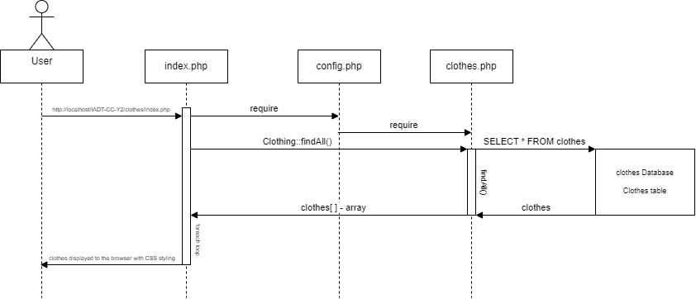

# Testing

* 1. Introduction

This chapter describes the testing that has been undertaken for the application. This chapter is presented in two sections:

1. Functional Testing
2. User Testing

Functional testing is a type of software testing whereby the system is tested against the functional requirements. The app is tested by looking to see if the actual output for a given input corresponds with the expected output. The tests should be based on the requirements for the app. The results of functional testing can indicate if a piece of software is functional and working, but not if the software is easy to use.

User testing looks to see if a piece of software is easy and intuitive for the user.

* 1. Functional Testing

This section describes the functional tests which were carried out on the app. These functional tests can be categorised as: (whatever is relevant to your app)

* Login/Registration
* Navigation
* Calculation
* CRUD

Functional testing generally uses a Black Box Testing technique which means that the internal logic of the system being tested is not of interest to the tester. The tester is only interested in whether the actual output agrees with the expected output.

* + 1. Login/Registration

|  |  |  |  |  |  |
| --- | --- | --- | --- | --- | --- |
| Test No | Description of test case | Input | Expected Output | Actual Output | Comment |
|  |  |  |  |  |  |
|  |  |  |  |  |  |
|  |  |  |  |  |  |

* + 1. Navigation

|  |  |  |  |  |  |
| --- | --- | --- | --- | --- | --- |
| Test No | Description of test case | Input | Expected Output | Actual Output | Comment |
|  |  |  |  |  |  |
|  |  |  |  |  |  |
|  |  |  |  |  |  |

* + 1. Calculation

|  |  |  |  |  |  |
| --- | --- | --- | --- | --- | --- |
| Test No | Description of test case | Input | Expected Output | Actual Output | Comment |
|  |  |  |  |  |  |
|  |  |  |  |  |  |
|  |  |  |  |  |  |

* + 1. CRUD

|  |  |  |  |  |  |
| --- | --- | --- | --- | --- | --- |
| Test No | Description of test case | Input | Expected Output | Actual Output | Comment |
|  |  |  |  |  |  |
|  |  |  |  |  |  |
|  |  |  |  |  |  |

### Discussion of Functional Testing Results

Describe the results from the tests. Address any functionality where unexpected behavior could not be debugged.

* 1. User Testing
  2. Conclusion

Discussion of test results.

# Project Management

## Introduction

This chapter describes how the project was managed. It shows the phases of the project, going from the project idea through the requirements gathering, the specification for the project, the design, implementation and testing phases for the project. It also discusses GitHub as a tool which assists in project management.

## Project Phases

In this section, describe each of the following project phases. Explain any issues which arose for each of the phases.

### Requirements

### Design

### Implementation

### Testing

Include a Gantt chart

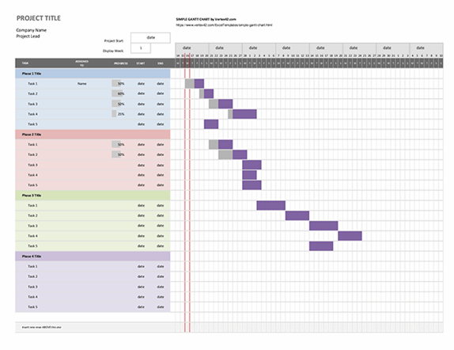

## SCRUM Methodology (optional)

Sprints

## Project Management Tools

### GitHub Project

Description

Include screen shots

How it worked in practice

### GitHub

Description

How it is used

How it worked in practice

# Reflection

## Your views on the project

Describe how you feel the project went from your perspective.

## How could the project be developed further?

## Assessment of your learning.

Critically assess your learning. List what skills and competencies you have learned developed in this Continuous Assessment.

List which part of the project would need further development and itemize where you feel you have not satisfactorily completed the continuous assessment.

## Completing a large software development project

Describe what you have learnt from the project, from the point of view of completing a large software development project.

## Technical skills

Describe what you have learnt from the project, from a technical skills viewpoint.

## Further competencies and skills

Describe any extra competencies and skills that would help you with your development in the workplace.

# References

Add a list of references that you used to complete the project.

The Department of Technology and Psychology in IADT uses APA 7th referencing style.

Use alphabetical order for your references.

This site gives details about how to cite websites using APA:

https://www.wikihow.com/Cite-a-Website-in-APA

The following is a useful site for creating citations for APA for websites.

<http://www.citationmachine.net/apa/cite-a-website>

You can also use the Referencing tab within Microsoft Word to enter reference information manually. Word then creates an APA style reference.